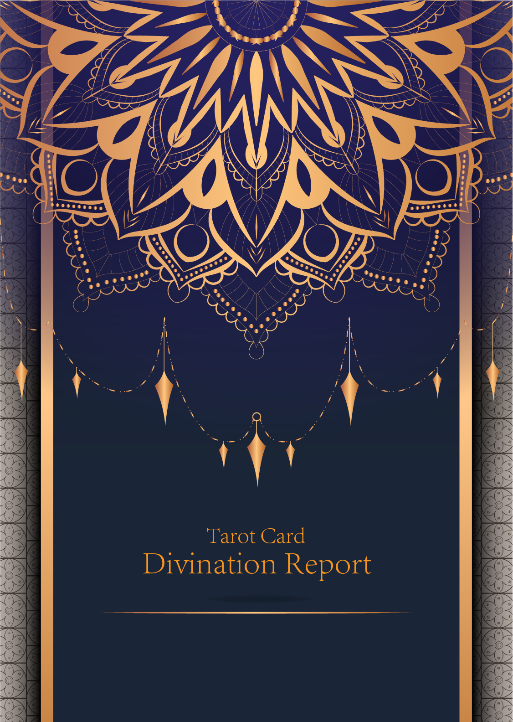

|  |
| --- |
| February 23, 2024 |

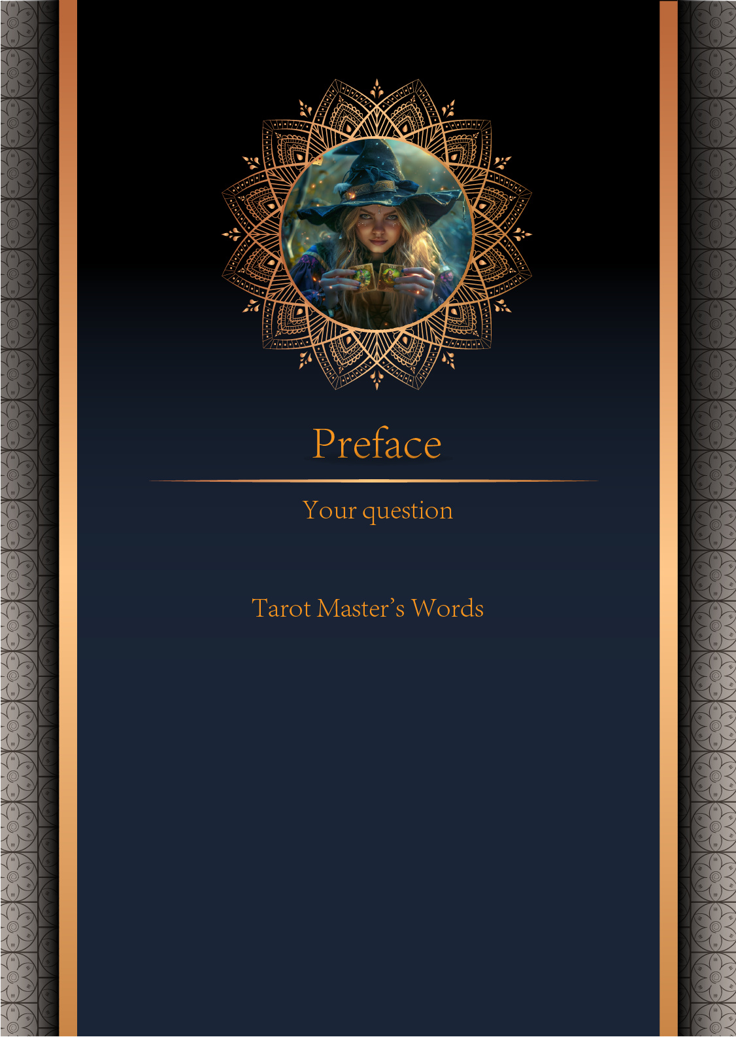

|  |
| --- |
| 我什么时候能结婚 |

|  |
| --- |
| Before we begin the interpretation, I would like to explain some important points to you. Tarot cards are not tools for predicting the future, but rather tools for guiding us to delve deeper into various situations in life. Therefore, when receiving the reading, please maintain an open mindset and trust your intuition. Our goal is to provide you with inspiration and guidance through the guidance of the tarot cards, helping you better deal with challenges and decisions in life. Alright, you can start reading now! |

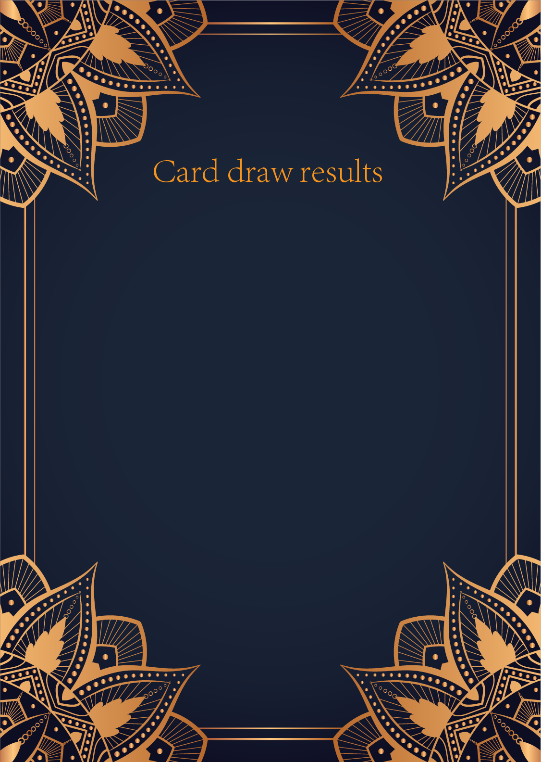

|  |
| --- |
| CardⅠ The Sun |
|  |
| The Sun card presents an feeling of optimism and fulfillment. This card represents the dawn which follows the darkest of nights. The Sun is the source of all the life on our planet, and it represents life energy itself. There is a child depicted in the card, playing joyfully in the foreground. A symbol of our innocence, it represents the happiness that occurs when you are in alignment with your true self. The child is naked, meaning that he has absolutely nothing to hide. The card also depicts the childhood innocence and absolute purity. This is particularly emphasized through the white horse upon which the child is riding. The horse here is also a symbol of strength and nobility. |

|  |
| --- |
| CardⅡ The Moon |
|  |
| When we encounter the Moon, we see a path that leads off into the distance. On either side of the path stand a wolf and a dog, representing our animalistic nature - one is civilized, and the other wild and feral. There is a crawfish that is crawling out of the pond from which the path stems from. In the distance, we can see two towers flanking the central path, once again alluding to the doubles visible in this card. Everything in this card seems to echo the other, as if to allude to two possibilities. When we walk down the path, we walk the fine line between conscious and unconscious, between the tamed side of civilization of the dog, and the forces of nature represented by the wolf. |

|  |
| --- |
| CardⅢ The Star |
|  |
| The Star card shows a woman kneeling at the edge of a small pond. She is holding two containers of water. One container pours the water out to the dry land, as if to to nourish it and ensure its fertility. The lush green land around her seems to say that it is working. One foot is inside the water which shows the spiritual abilities and inner strength of the woman. The other foot on the ground shows her practical abilities and strengths. Behind her, there is a large central star surrounded by seven small stars which represent the chakras. There is bird standing at a tree branch which represents the holy ibis of thought. The Star's astrological correspondent is Aquarius. |

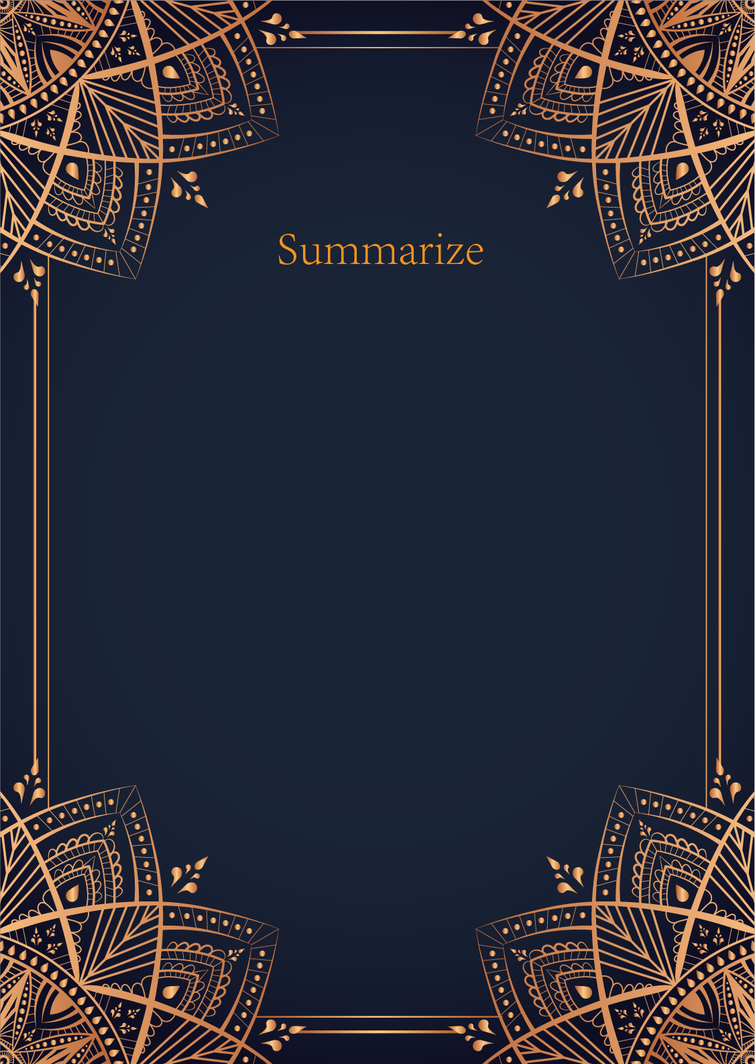

|  |
| --- |
| Ah, my dear seeker, the cards have revealed a message from the universe regarding your question about marriage. The Sun, Moon, and Star are powerful symbols of illumination, cycles, and guidance.  The Sun card shining brightly in your spread signifies a time of joy, fulfillment, and success in your love life. It suggests that a marriage may be on the horizon for you, filled with warmth, happiness, and positive energy. This card represents clarity and illumination, indicating that the path to marriage may become clear to you sooner than you expect.  The Moon card, with its mysterious and intuitive energy, hints at a period of emotional depth and spiritual growth before you enter into a marriage. It suggests that there may be some hidden emotions or fears that need to be addressed before you can fully embrace this new chapter in your life. Trust your intuition during this time, as it will guide you towards greater understanding and self-awareness.  Finally, the Star card twinkles in the night sky, offering hope, inspiration, and guidance on your journey towards marriage. This card encourages you to have faith in the universe and to believe in the power of your dreams. It indicates that your wishes and desires for marriage are within reach, as long as you continue to stay true to yourself and follow your inner light.  Overall, the cards are telling you that the timing for marriage is auspicious, filled with light, intuition, and hope. Trust in the process, continue to work on your personal growth, and remain open to the opportunities that come your way. The universe is aligning in your favor, and before you know it, you may find yourself walking down the aisle towards a beautiful and fulfilling marriage. Embrace the journey with an open heart, for love is on the horizon. |

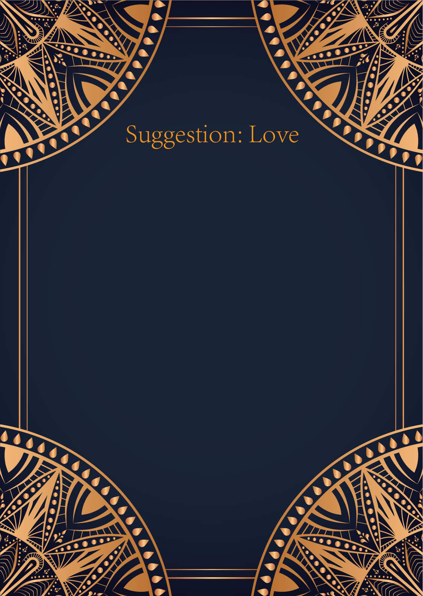

|  |
| --- |
| Ah, the Sun, the Moon, and the Star. What a powerful combination of cards you have drawn, my dear seeker. In matters of love, these cards speak of clarity, intuition, and guidance from the universe.   The Sun card represents joy, success, and vitality. It suggests that you are feeling confident and enthusiastic about your romantic prospects. Embrace this positive energy and let it shine brightly in your interactions with others. Be open, be joyful, and allow yourself to bask in the warmth of love's light.  The Moon card, on the other hand, speaks to the realm of emotions, intuition, and hidden truths. It reminds you to trust your instincts and listen to the whispers of your heart. Love is not always a straightforward path, and there may be moments of uncertainty or confusion. Embrace the mystery, explore your emotions, and allow yourself to be vulnerable in matters of the heart.  And finally, the Star card brings hope, inspiration, and a sense of destiny. It signifies that you are on the right path, guided by the wisdom of the cosmos. Believe in the power of love to heal, to inspire, and to lead you towards your true desires. Keep your faith strong, keep your vision clear, and know that the universe is conspiring in your favor.  In conclusion, my dear seeker, my advice to you in matters of love is this: embrace the joy and vitality that love brings, trust in your intuition and emotions, and stay true to your hopes and dreams. Remember that love is a journey, and the cards are aligned in your favor. Trust in the magic of the universe, and let your heart guide you towards the love you seek. Love is a beautiful, mysterious, and wondrous adventure – embrace it fully and without fear. Blessed be. |

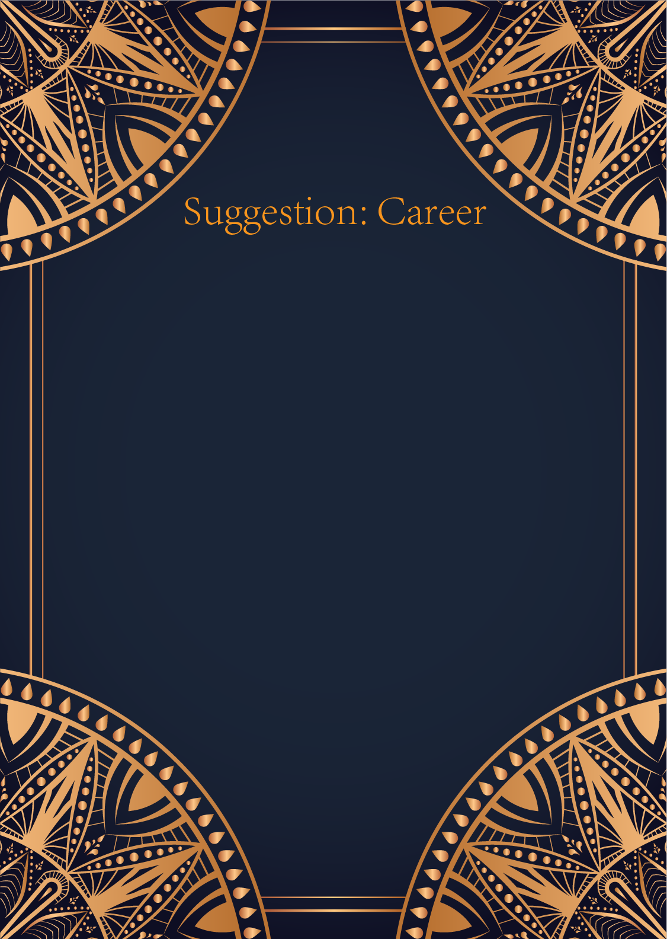

|  |
| --- |
| Ah, my dear seeker of guidance, the cards you have drawn are truly illuminating. The Sun, the Moon, and the Star – a powerful trio indeed. The Sun represents success, vitality, and abundance in your career path. It signifies that now is a time of great potential and growth for you. Your talents and abilities are shining brightly, and you are on the right path towards achieving your goals.  The Moon, on the other hand, speaks to the realm of intuition, creativity, and the subconscious mind. It indicates that there may be hidden obstacles or uncertainties in your professional life that you need to address. Trust your instincts and pay attention to any intuitive nudges guiding you towards the right decisions. Embrace the unknown and have faith that your inner wisdom will lead you in the right direction.  Ah, and the Star, the beacon of hope and inspiration. This card is a sign of renewal, guidance, and faith in the universe. It encourages you to dream big and believe in the power of your aspirations. Your career path is illuminated by the light of the Star, guiding you towards your true purpose and destiny.  In combining these three cards, the message for you is clear: embrace the success and abundance that the Sun offers, trust your intuition and navigate through uncertainties with the wisdom of the Moon, and have faith in the universe's guidance and your own inner light, as shown by the Star.  Remember, my dear, your career journey is a beautiful tapestry woven with the threads of your passion, determination, and vision. Embrace the opportunities that come your way, trust in your own abilities, and let the universe guide you towards the fulfillment of your professional dreams. The path ahead is bright and filled with endless possibilities. Trust in the cards, trust in yourself, and trust in the magic of the universe. |

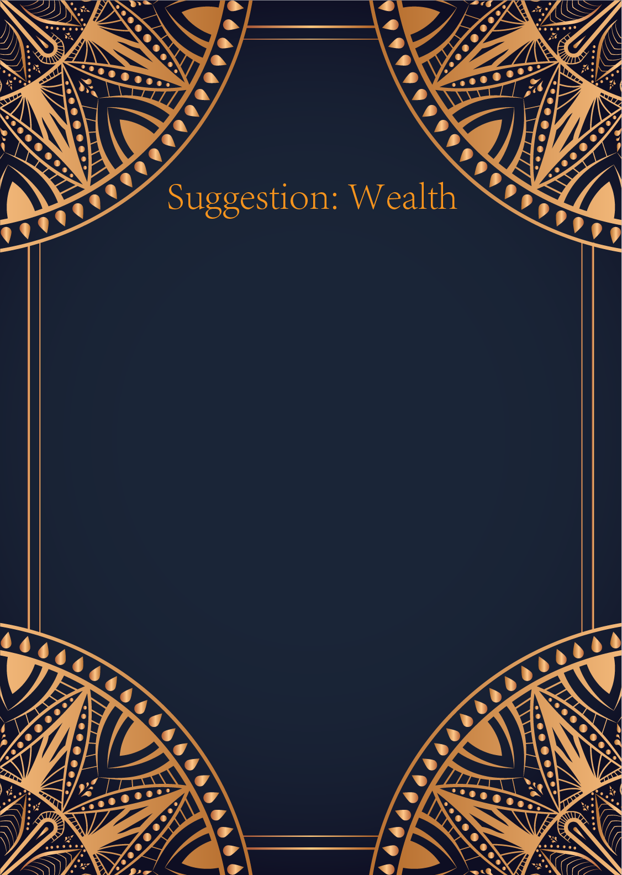

|  |
| --- |
| Ah, dear seeker, the cards you have drawn - The Sun, The Moon, and The Star - speak of abundance, intuition, and guidance in your financial matters. The Sun shines brightly upon you, bringing success and prosperity into your life. It signifies a time of growth and achievement, where your hard work will be rewarded. This card advises you to seize opportunities that come your way and to have confidence in your abilities.  The Moon, with its mysterious light, urges you to trust your intuition when making financial decisions. Pay attention to your dreams and inner feelings, for they may hold valuable insights. Beware of illusions and deception, and seek clarity in all your dealings. This card suggests that not everything is as it seems, so proceed with caution and rely on your inner guidance.  And finally, The Star shines down upon you with hope and inspiration. It symbolizes guidance and direction in your financial endeavors. This card encourages you to set clear goals and to believe in your own potential. It indicates that a bright future lies ahead, filled with opportunities for growth and fulfillment. Stay true to your vision and let your inner light guide you towards success.  In summary, dear seeker, the cards advise you to embrace the abundance of The Sun, trust your intuition like The Moon, and seek guidance and inspiration from The Star. Remember to stay grounded in reality, trust your instincts, and believe in the bright future that awaits you. May the energies of these cards bring you prosperity and clarity in your financial journey. |

